**Chapter 6 Payment Voucher**

This section manages and keeps track your payment voucher for you.

You can generate payment voucher easily with predefine activity and locate a payment voucher quickly with system search function.

This system is able to generate a payment voucher with more than one file.

*In This Chapter:*

*6.1 Payment Voucher (Office Account)*

*6.1.1 New Pv (Office A/C) – Cash*

*6.1.2 New Pv (Office A/C) – DIS / RIB*

*6.1.3 New Pv (Office A/C) – Others*

*6.1.4 New Commission Payout*

*6.1.5 New Incentive Payout*

*6.1.6 Manage Pv (Office A/C)*

*6.1.6.2 Delete Pv (Office A/C)*

*6.2 Payment Voucher (Clients’ Account)*

*6.2.1 New Pv (Clients’ A/C) – DIS / RIB*

*6.2.2 New Pv (Clients’ A/C) – MHIT*

*6.2.3 New Pv (Clients’ A/C) – Others*

*6.2.4 Manage Pv (Clients’ A/C)*

*6.2.4.1 Delete Pv (Clients’ A/C)*

*6.3 Account Payable Payment*

*6.3.1 New A/P Payment*

*6.3.2 Manage A/P Payment*

*6.3.2.1 Delete A/P Payment*

*6.4 Cheque Return Function*

*6.5 Manage Returned Cheque*

*6.6 Payment Voucher Approval*

**6.1 Payment Voucher (Office Account)**

* To open Payment Voucher window, click ‘**Payment**’ on navigation bar and select a payment voucher according to payment term.
* 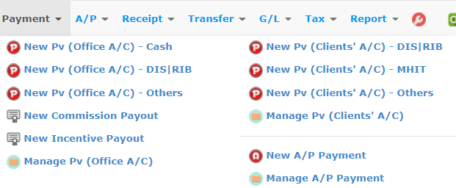

**6.1.1 New Pv (Office A/C) – Cash**

This function should be used to generate payment voucher when the payment method is cash.

* To begin, choose ‘**New Pv (Office A/C) – Cash**’ and a window will appear as below.

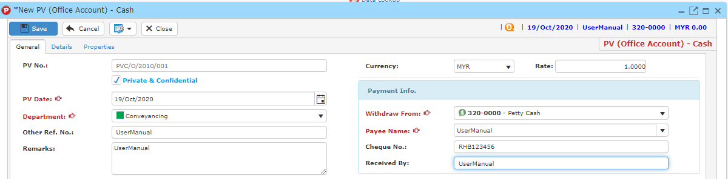

* PV No is mandatory (auto generated or manually type in is according to ref no setup).
* Tick the ‘Private and Confidential’ checkbox if you want this PV as a Private and confidential PV.



* Complete any field for information you want to record.
* You must add an item into the payment voucher in order to generate a payment voucher. Click ‘**Details**’ tab, a form will show up as shown in the image below.

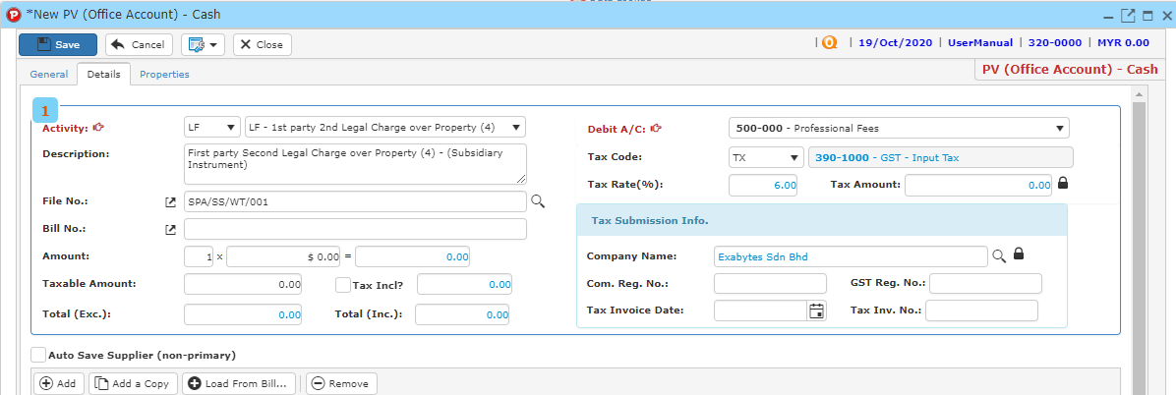

* Type amount for each item in the payment voucher.
* Click ‘**Add’** button to add item into the record list.
* You may also click ‘**Remove**’ button after clicking on the item that you wish to remove to remove the item from the record list.
* Clickbutton to search file no.
* Enter searching criteria then click the ‘**Search**’ button.

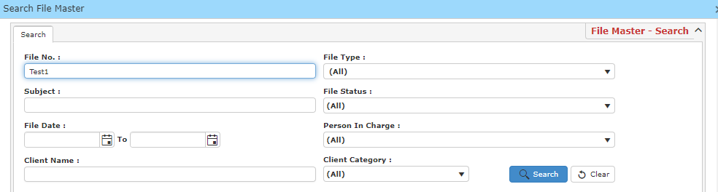

* A result list will be displayed and choose the file you want to be linked with the payment voucher.

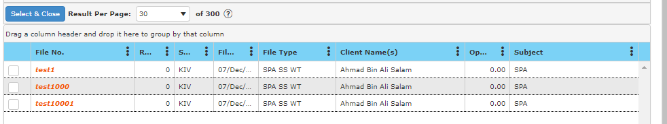

* Click ‘S**elect & Close**’ to proceed.
* Once you have completed, click ‘**Save**’ to save payment voucher information.
* Click ‘**Preview**’ to have a look at the receipt, and you may print out there payment

voucher here.

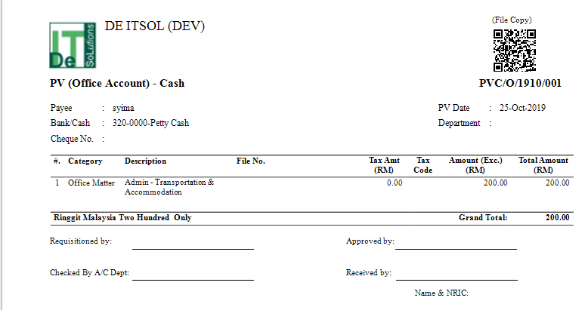

**Load from Bill**

* To load from bill, click **Load From Bill** and a new window will be displayed.

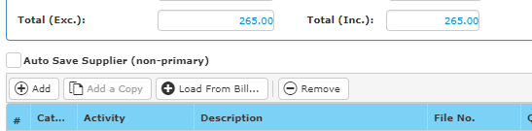

* Enter your search criteria and click **Search**, a result list will be displayed as below.

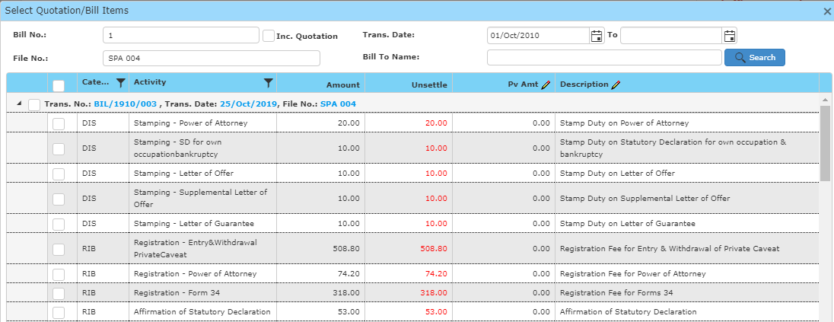

* Tick the checkboxes to load the item from bill into the PV. Click **OK** once you have finished.

**6.1.2 New Pv (Office A/C) – DIS / RIB**

This function should be used to generate payment voucher when the payment method is disbursement or reimbursement.

* To begin, choose ‘**New Pv (Office A/C) – DIS / RIB**’.

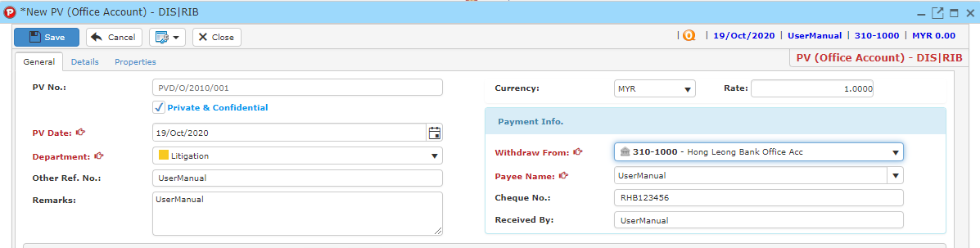

* PV No is mandatory (auto generated or manually type in is according to ref no setup).
* Tick the ‘Private and Confidential’ checkbox if you want this PV as a Private and confidential PV.



* Complete any field for information you want to record.
* You must add an item into the payment voucher in order to generate a payment voucher. Click ‘**Details**’ tab, a form will show up as shown in the image below.

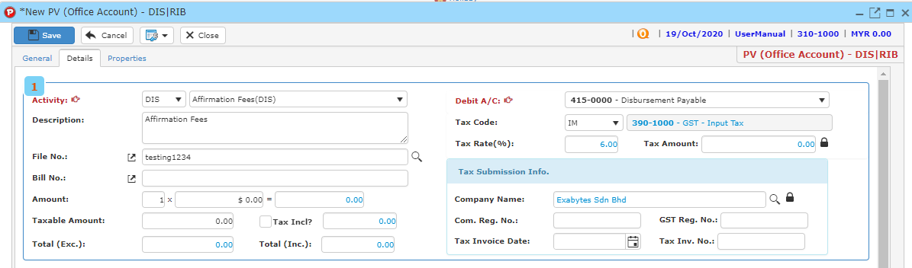

* Type amount for each item in the payment voucher.
* Click ‘**Add’** button to add item into the record list.
* You may also click ‘**Remove**’ button after clicking on the item that you wish to remove to remove the item from the record list.
* Clickbutton to search file no.
* Enter searching criteria then click the ‘**Search**’ button.



* A result list will be displayed and choose the file you want to be linked with the payment voucher.



* Click ‘S**elect & Close**’ to proceed.
* Once you have completed, click ‘**Save**’ to save payment voucher information.
* Click ‘**Preview**’ to have a look at the receipt, and you may print out there payment voucher here.

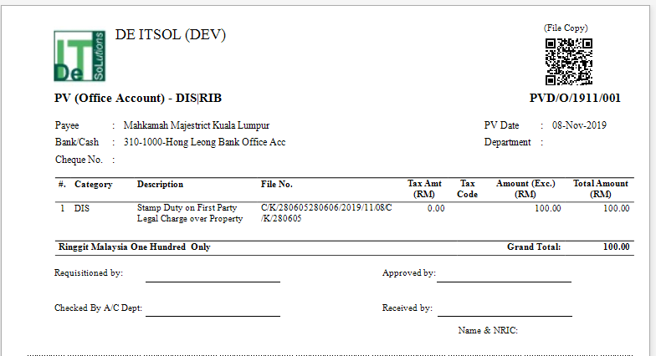

**Load from Bill**

* To load from bill, click **Load From Bill** and a new window will be displayed.



* Enter your search criteria and click **Search**, a result list will be displayed as below.



* Tick the checkboxes to load the item from bill into the PV. Click **OK** once you have finished.

**6.1.3 New Pv (Office A/C) – Others**

This function should be used to generate payment voucher when the payment method does not match any other options.

* To begin, choose ‘**New Pv (Office A/C) – Others**’.

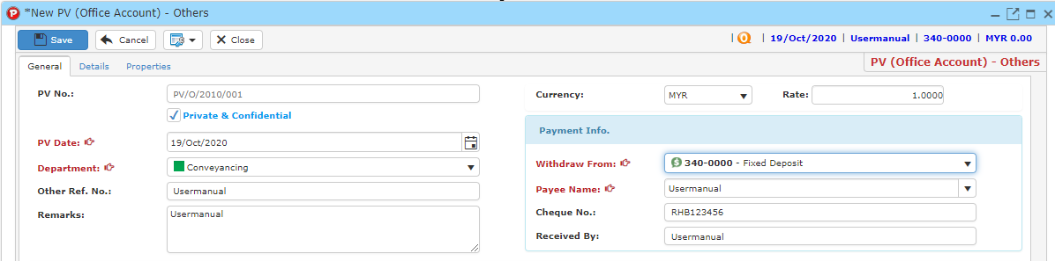

* PV No is mandatory (auto generated or manually type in is according to ref no setup).
* Tick the ‘Private and Confidential’ checkbox if you want this PV as a Private and confidential PV.



* Complete any field for information you want to record.
* You must add an item into the payment voucher in order to generate a payment voucher. Click ‘**Details**’ tab, a form will show up as shown in the image below.

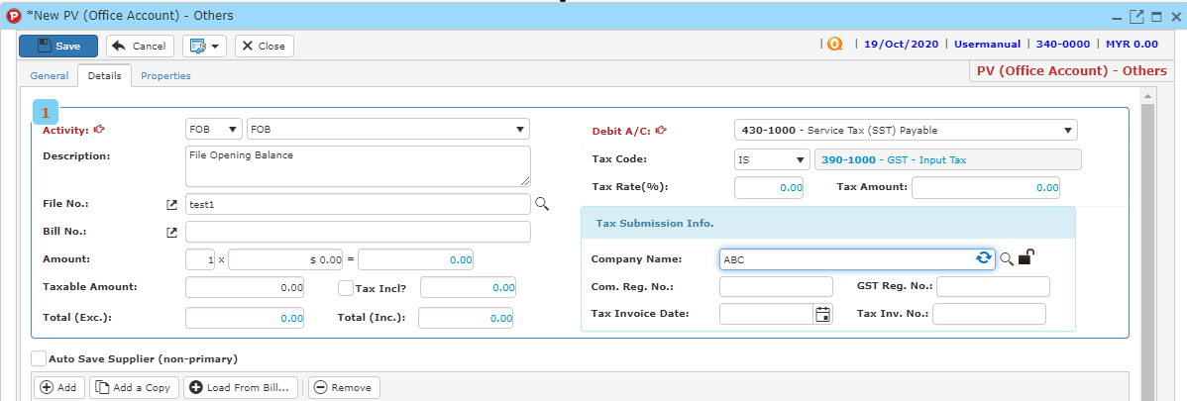

* Type amount for each item in the payment voucher.
* Click ‘**Add’** button to add item into the record list.
* You may also click ‘**Remove**’ button after clicking on the item that you wish to remove to remove the item from the record list.
* Clickbutton to search file no.
* Enter searching criteria then click the ‘**Search**’ button.



* A result list will be displayed and choose the file you want to be linked with the payment voucher.



* Click ‘S**elect & Close**’ to proceed.
* Once you have completed, click ‘**Save**’ to save payment voucher information.
* Click ‘**Preview**’ to have a look at the receipt, and you may print out there payment voucher here.

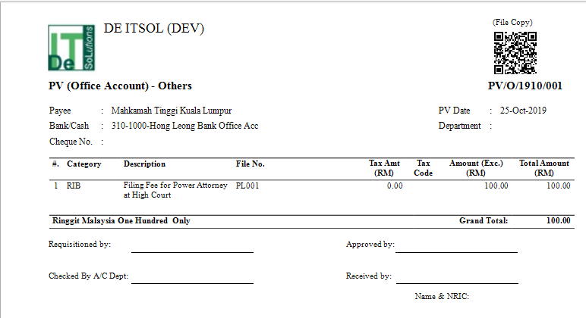

**Load from Bill**

* To load from bill, click **Load From Bill** and a new window will be displayed.



* Enter your search criteria and click **Search**, a result list will be displayed as below.



* Tick the checkboxes to load the item from bill into the PV. Click **OK** once you have finished.

**6.1.4 New Commission Payout**

**Setting up Commission Payout**

* Go to **Maintenance > Activity**.
* Choose an activity and tick the checkbox for **commission entitled** for the chosen activity.

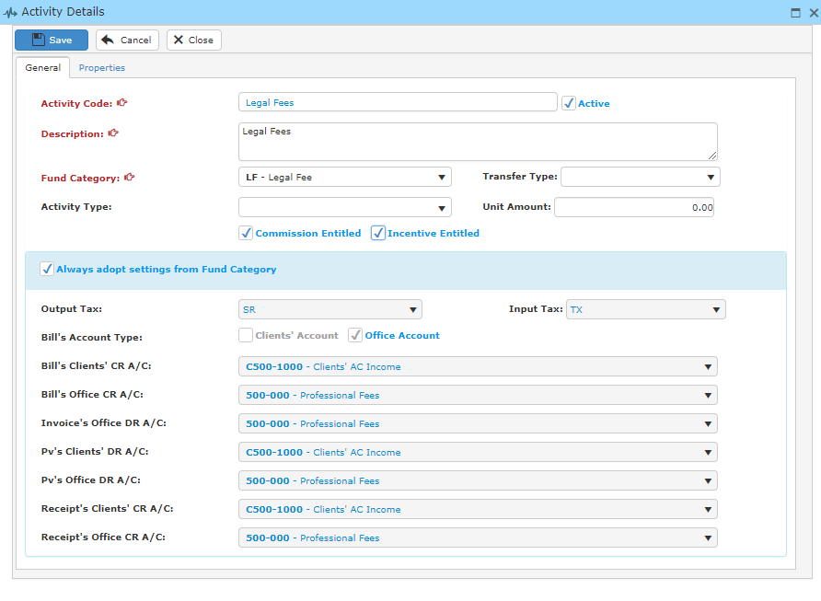

* Next, go to **Maintenance > Agent**
* Setup your agent here by clicking **New Agent**.

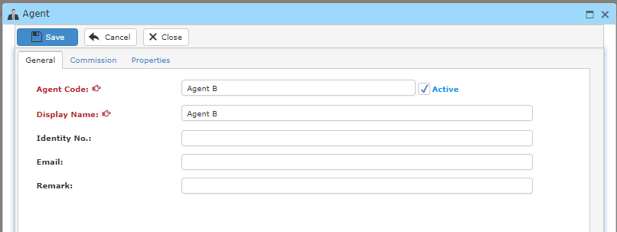

* To setup a new commission
* Click **New Agent > Commission**

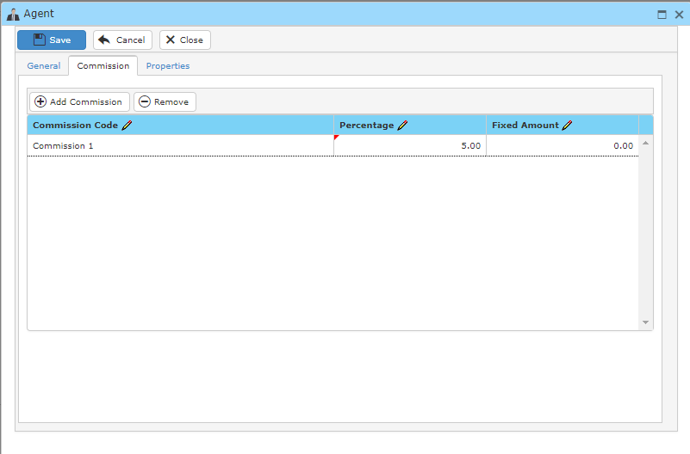

* To setup commission agent code, go to **Maintenance > Data Lookup > Agent Commission Code**

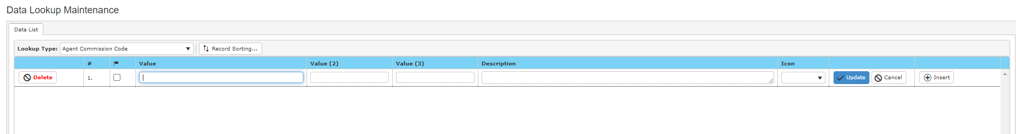

* Once you are done filling in the fields, click save.

**Creating a bill that is entitled for Commission payout**

* Go to **File> Manage File** and enter your search criteria.
* Select a file by double clicking them and click **Edit** to add **Agent Commission** and **Staff Incentive**.

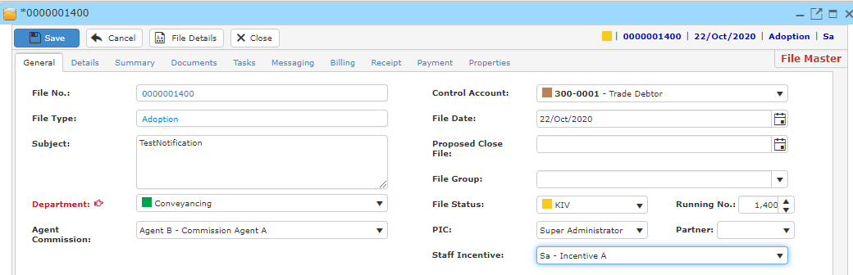

* Then go to **Billing** and create a new quotation.

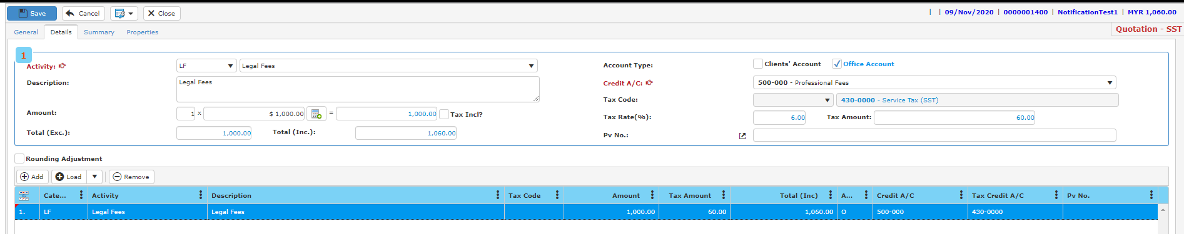

**Note: Remember to POST the quotation.**

**Commission Payout**.

* To create a new commission make sure you have created a bill that has an item that is entitled for commission, on the “**Payment**” Menu, click ‘**New Commission Payout**’.



* A new window will display as below.

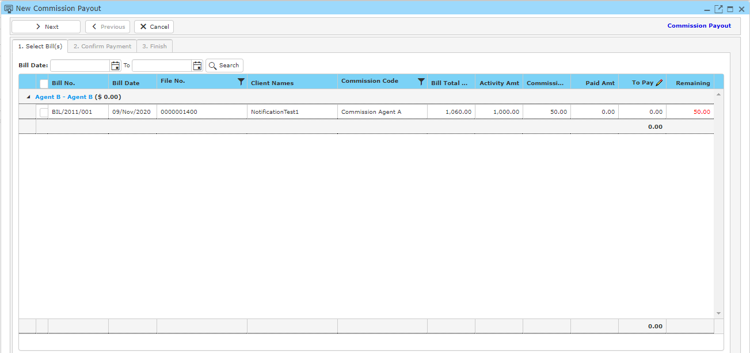

* Tick the checkbox for the correct bill and click **Next**.

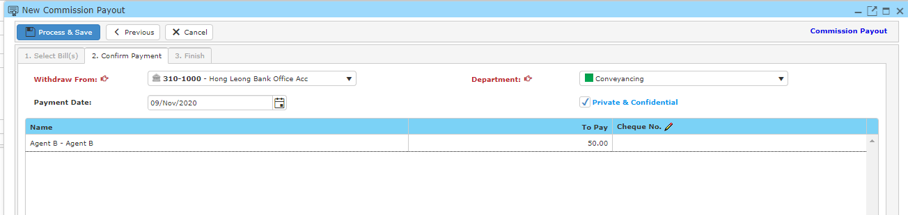

* Select an account for **Withdraw From** and **Department** and click **Process & Save**.

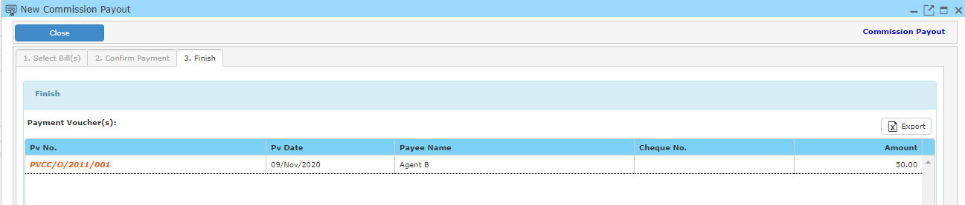

* The payout is completed.

**6.1.5 New Incentive Payout**

**Setting up Incentive Payout**

* Go to **Maintenance > Activity**.
* Choose an activity and tick the checkbox for **incentive entitled** for the chosen activity.



* Then, setup staff incentive code by going **Maintenance > Data Lookup Maintenance**.
* Create an Incentive code by filling in the blank, click **Update** when you are done.



* Next, go to **Maintenance > User Account Details** to setup incentive for a staff.
* Double click a user and a window will appear as below.

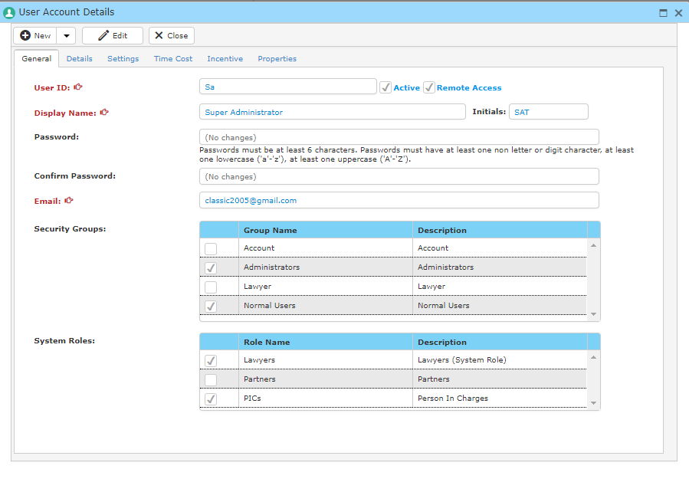

* Click on incentive and click on **Add Incentive** to add new incentive to the staff.

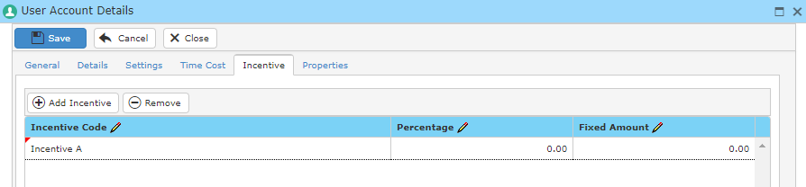

**Creating a bill that is entitled for Incentive payout**

* Go to **File> Manage File** and enter your search criteria.
* Select a file by double clicking them and click **Edit** to add **Agent Commission** and **Staff Incentive**.



* Then go to **Billing** and create a new quotation.



**Note: Remember to POST the quotation.**

**New Incentive Payout**

* To create a new commission, on the “**Payment**” Menu, click ‘**New Incentive Payout**’.



* A new window will display as below.

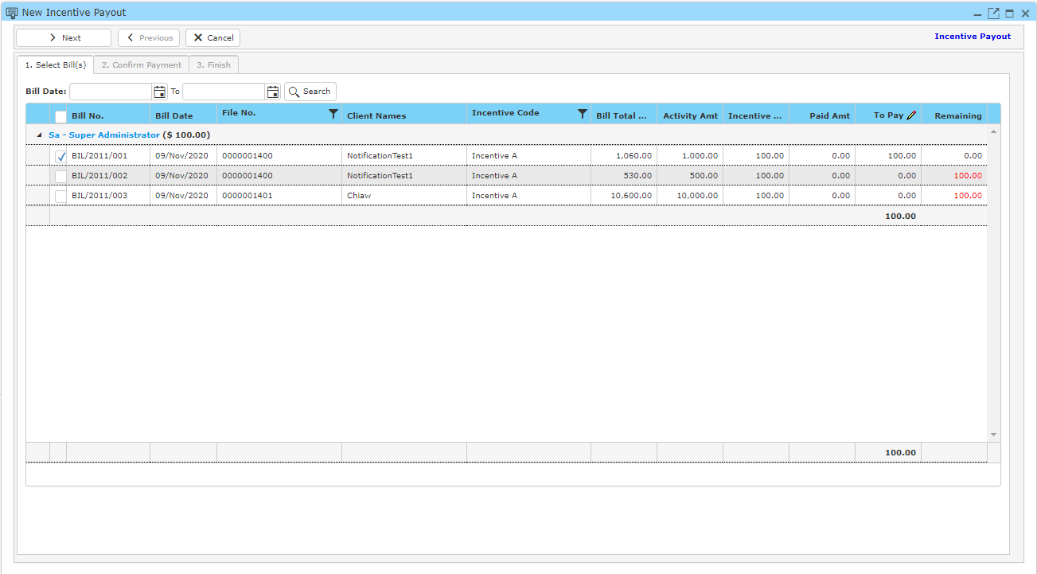

* Tick the checkbox for the correct bill and click **Next**.

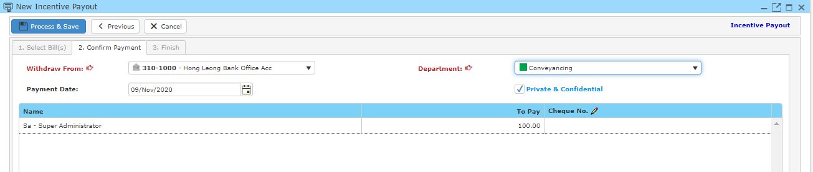

* Select an account for **Withdraw From** and **Department** and click **Process & Save**.

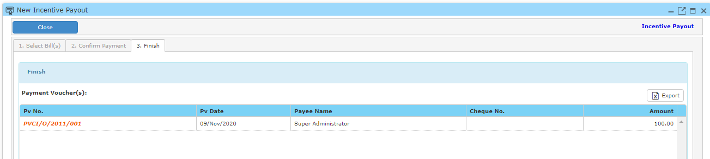

* The payout is completed.

**6.1.6 Manage P/v (Office A/C)**

* To find a payment voucher for office account, on the ‘**Payment**’ Menu, click ‘**Manage Pv (Office A/C)** ’.



* Type your search criteria to begin.

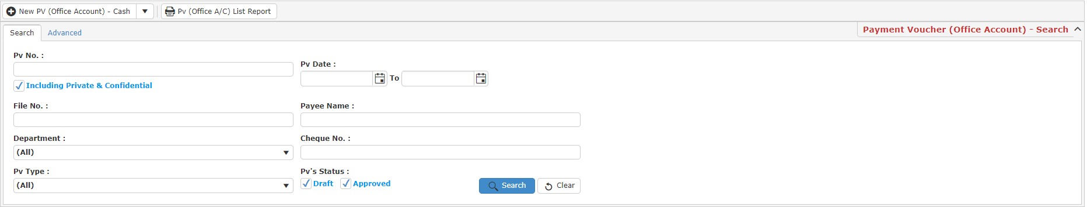

* Click ‘**Search**’ and search results will display at search record list. You can open an item in the search results list by double-clicking.
* Click ‘**Export**’ to print the desired search result in excel, pdf or csv format.

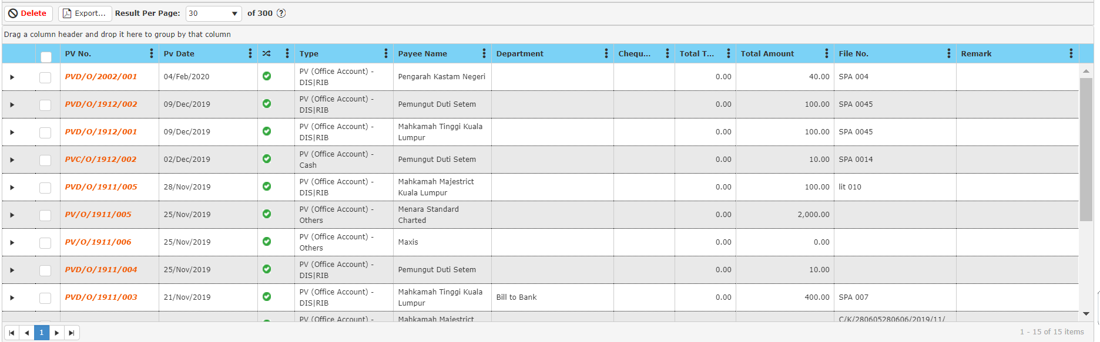

* After double clicking an item, click ‘**Preview**’ to print the desired search result.
* To start a new search or to clear the search results, close the pop-up window and click ‘**Clear**’.

**Delete Payment Voucher**

* To delete a payment voucher, select the payment voucher in the search record list after entering search criteria in the ‘**Manage Pv (Office A/C)**’ by ticking the box and click ‘**Delete**’.

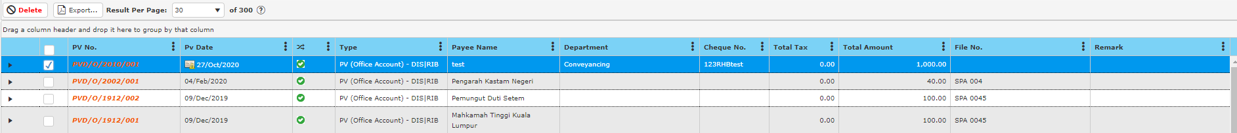

**6.2 Payment Voucher (Clients’ Account)**

* To open Payment Voucher window, click ‘**Payment**’ on navigation bar and select a payment voucher according to payment term.

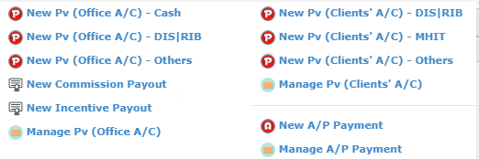

**6.2.1 New Pv (Clients’ A/C) – DIS / RIB**

This function should be used to generate payment voucher when the payment method is disbursement or reimbursement from client’s account.

* To begin, choose ‘**New Pv (Clients’ A/C) – DIS / RIB**’.

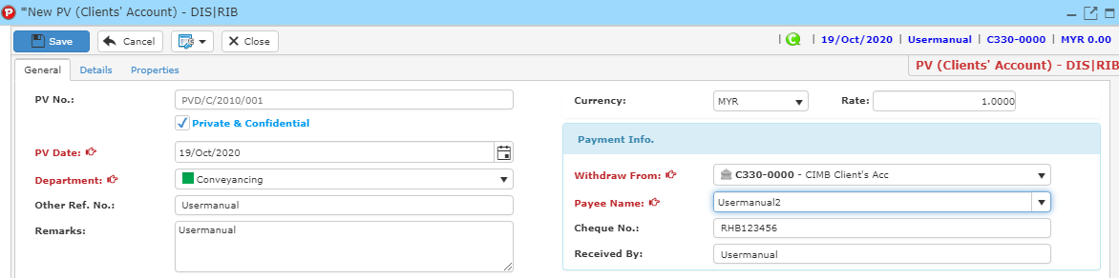

* PV No is mandatory (auto generated or manually type in is according to ref no setup).
* Tick the ‘Private and Confidential’ checkbox if you want this PV as a Private and confidential PV.



* Complete any field for information you want to record.
* You must add an item into the payment voucher in order to generate a payment voucher. Click ‘**Details**’ tab, a form will show up as shown in the image below.

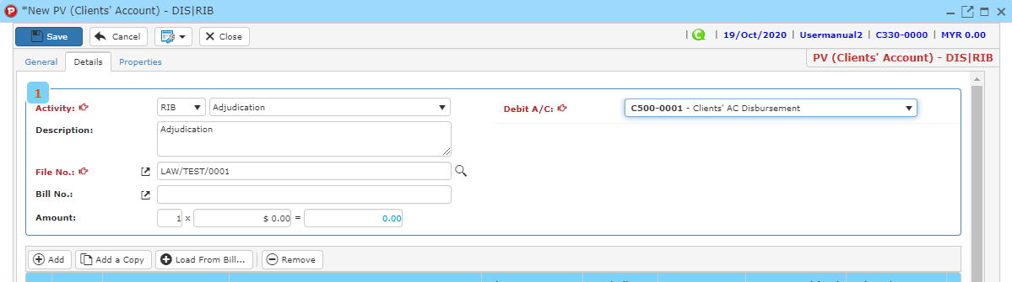

* Type amount for each item in the payment voucher.
* Click ‘**Add’** button to add item into the record list.
* You may also click ‘**Remove**’ button after clicking on the item that you wish to remove to remove the item from the record list.
* Clickbutton to search file no.
* Enter searching criteria then click the ‘**Search**’ button.



* A result list will be displayed and choose the file you want to be linked with the payment voucher.



* Click ‘S**elect & Close**’ to proceed.
* Once you have completed, click ‘**Save**’ to save payment voucher information.
* Click ‘**Preview**’ to have a look at the receipt, and you may print out there payment voucher here.

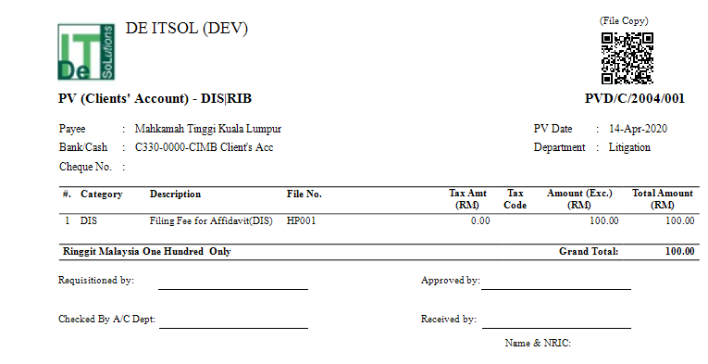

**Load from Bill**

* To load from bill, click **Load From Bill** and a new window will be displayed.



* Enter your search criteria and click **Search**, a result list will be displayed as below.



* Tick the checkboxes to load the item from bill into the PV. Click **OK** once you have finished.

**6.2.2 New Pv (Clients’ A/C) – MHIT**

This function should be used to generate payment voucher when the payment method is by stakeholder’s money from client’s account.

* To begin, choose ‘**New Pv (Clients’ A/C) – MHIT**’.

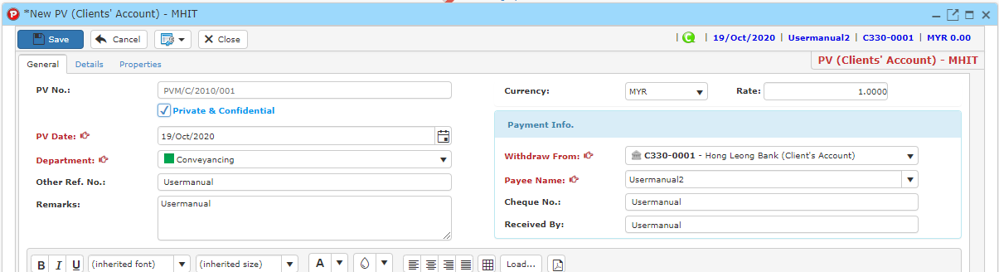

* PV No is mandatory (auto generated or manually type in is according to ref no setup).
* Tick the ‘Private and Confidential’ checkbox if you want this PV as a Private and confidential PV.



* Complete any field for information you want to record.
* You must add an item into the payment voucher in order to generate a payment voucher. Click ‘**Details**’ tab, a form will show up as shown in the image below.

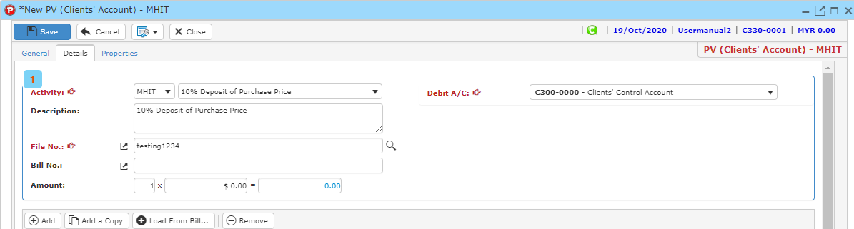

* Type amount for each item in the payment voucher.
* Click ‘**Add’** button to add item into the record list.
* You may also click ‘**Remove**’ button after clicking on the item that you wish to remove to remove the item from the record list.
* Clickbutton to search file no.
* Enter searching criteria then click the ‘**Search**’ button.



* A result list will be displayed and choose the file you want to be linked with the payment voucher.



* Click ‘S**elect & Close**’ to proceed.
* Once you have completed, click ‘**Save**’ to save payment voucher information.
* Click ‘**Preview**’ to have a look at the receipt, and you may print out there payment voucher here.

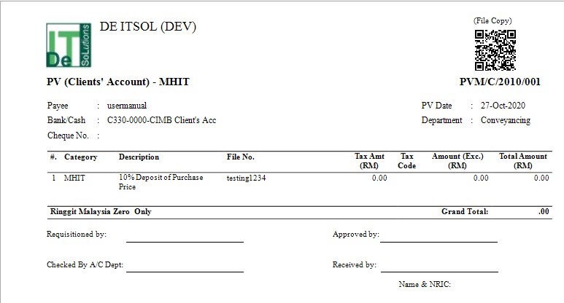

**Load from Bill**

* To load from bill, click **Load From Bill** and a new window will be displayed.



* Enter your search criteria and click **Search**, a result list will be displayed as below.



* Tick the checkboxes to load the item from bill into the PV. Click **OK** once you have finished.

**6.2.3 New Pv (Clients’ A/C) – Others**

This function should be used to generate payment voucher when the payment method does not meet the other options.

* To begin, choose ‘**New Pv (Clients’ A/C) – Others**’.

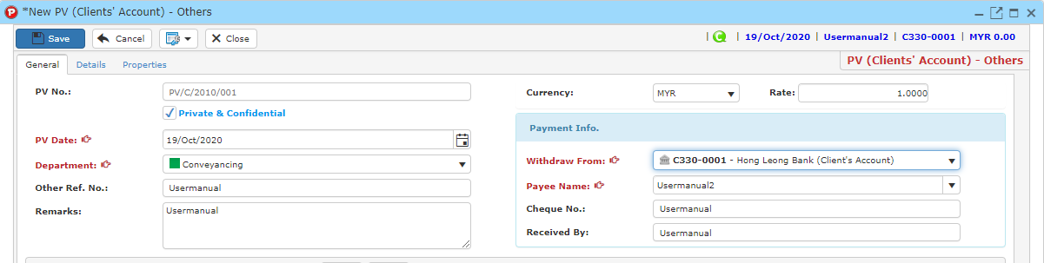

* PV No is mandatory (auto generated or manually type in is according to ref no setup).
* Tick the ‘Private and Confidential’ checkbox if you want this PV as a Private and confidential PV.



* Complete any field for information you want to record.
* You must add an item into the payment voucher in order to generate a payment voucher. Click ‘**Details**’ tab, a form will show up as shown in the image below.

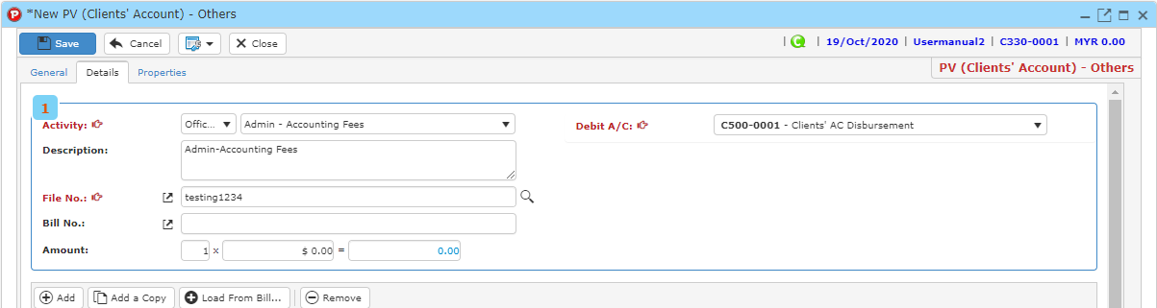

* Type amount for each item in the payment voucher.
* Click ‘**Add’** button to add item into the record list.
* You may also click ‘**Remove**’ button after clicking on the item that you wish to remove to remove the item from the record list.
* Clickbutton to search file no.
* Enter searching criteria then click the ‘**Search**’ button.



* A result list will be displayed and choose the file you want to be linked with the payment voucher.



* Click ‘S**elect & Close**’ to proceed.
* Once you have completed, click ‘**Save**’ to save payment voucher information.
* Click ‘**Preview**’ to have a look at the receipt, and you may print out there payment voucher here.

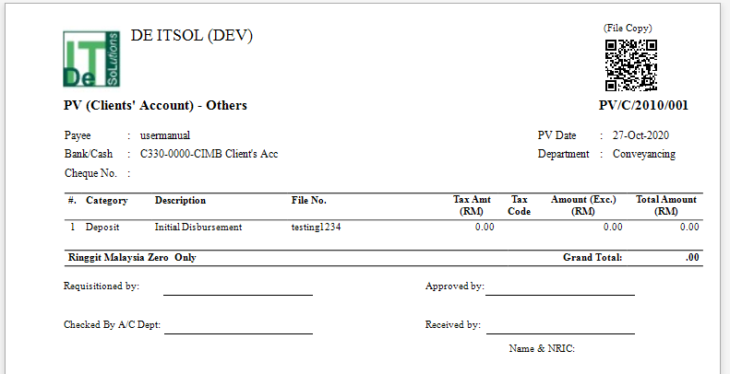

**Load from Bill**

* To load from bill, click **Load From Bill** and a new window will be displayed.



* Enter your search criteria and click **Search**, a result list will be displayed as below.



* Tick the checkboxes to load the item from bill into the PV. Click **OK** once you have finished.

**6.2.4 Manage Pv (Clients’ A/C)**

* To find a payment voucher for clients’ account, on the ‘**Payment**’ Menu, click ‘**Manage Pv (Clients’ A/C)** ’.



* Type your search criteria to begin.

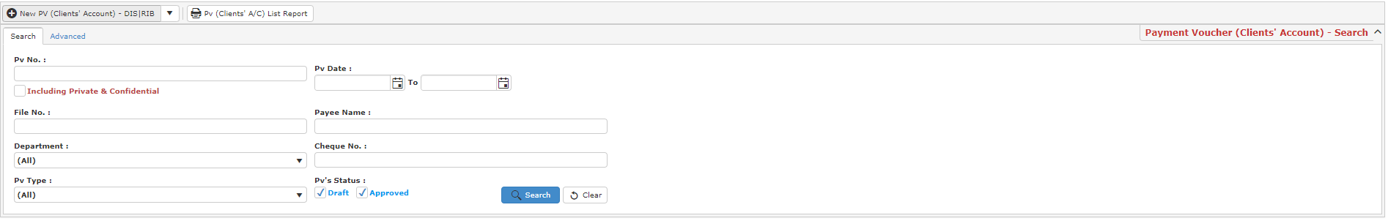

* Click ‘**Search**’ and search results will display at search record list. You can open an item in the search results list by double-clicking.
* Click ‘**Export**’ to print the desired search result in excel, pdf or csv format.

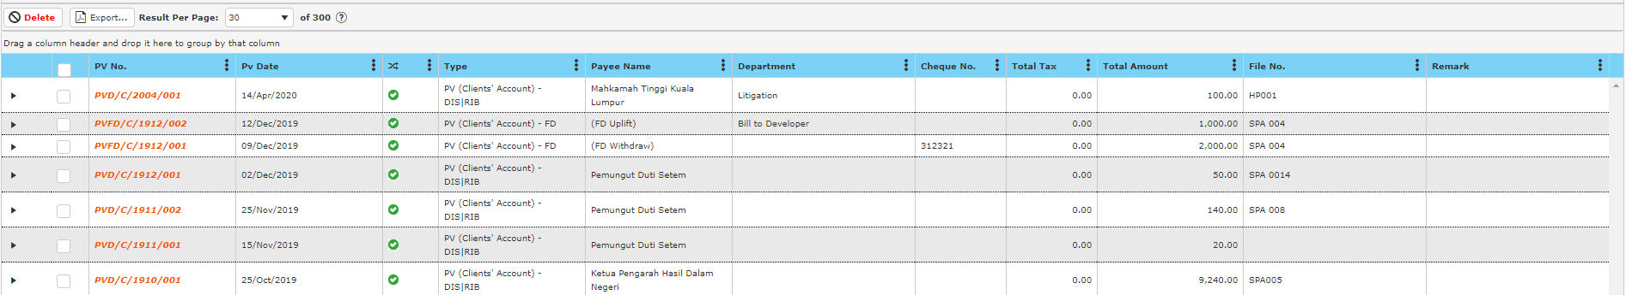

* After double clicking an item, click ‘**Preview**’ to print the desired search result.
* To start a new search or to clear the search results, close the pop-up window and click ‘**Clear**’.

**Delete Payment Voucher**

* To delete a payment voucher, select the payment voucher in the search record list after entering search criteria in the ‘**Manage Pv (Clients’ A/C)**’ by ticking the box and click ‘**Delete**’.



**6.3 Account Payable Payment**

* To open Payment Voucher window, click ‘**Payment**’ on navigation bar and select a payment voucher according to payment term.

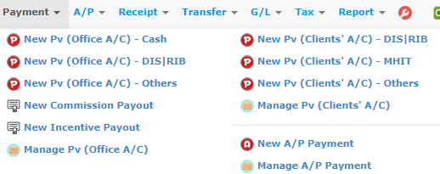

**6.3.1 New A/P Payment**

This function should be used to generate account payable payment voucher.

* To begin, choose ‘**New A/P Payment**’.

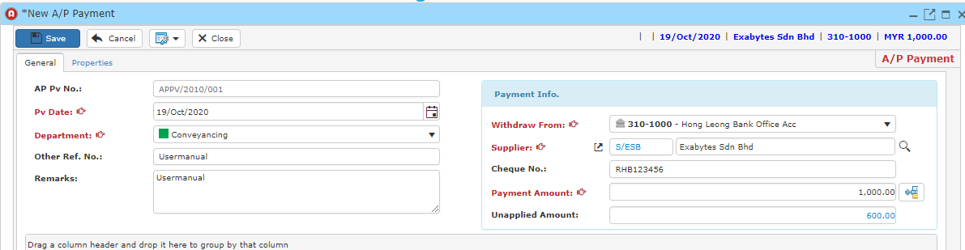

* PV No is mandatory (auto generated or manually type in is according to ref no setup).
* Complete any field for information you want to record.
* You must add a supplier into the payment voucher in order to generate a payment voucher.
* Clickbutton to search file no.

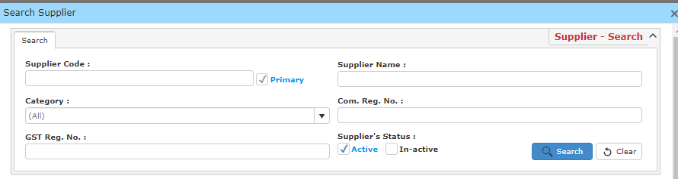

* Fill in any search criteria to find your supplier and click the ‘Search’ button.
* A result list will be displayed and choose the file you want to be linked with the payment voucher.

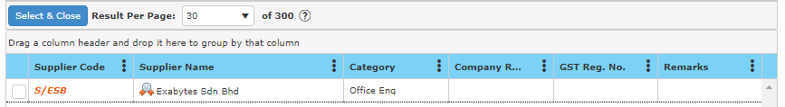

* Click ‘S**elect & Close**’ to proceed.
* Once you have completed, click ‘**Save**’ to save payment voucher information.
* Click ‘**Preview**’ to have a look at the receipt, and you may print out there payment voucher here.

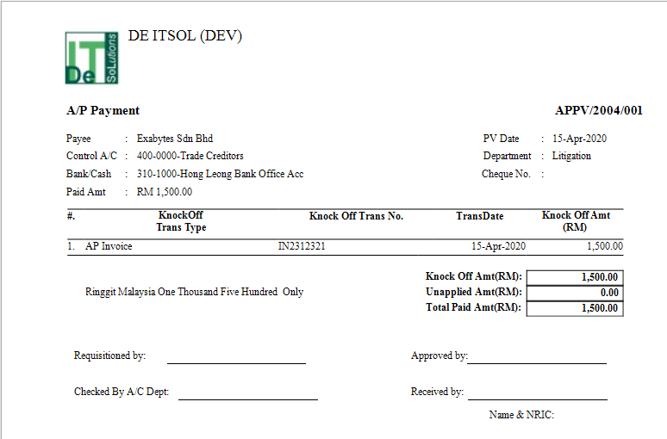

**6.3.2 Manage A/P Payment Voucher**

* To find a A/P Payment for clients’ account, on the ‘**Payment**’ Menu, click ‘**Manage A/P Payment**’.



* Type your search criteria to begin.

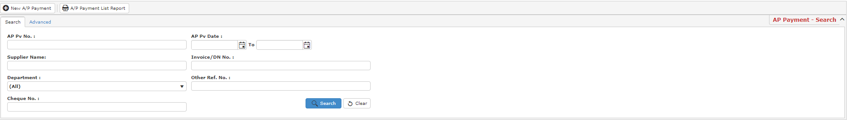

* Click ‘**Search**’ and search results will display at search record list. You can open an item in the search results list by double-clicking.
* Click ‘**Export**’ to print the desired search result in excel, pdf or csv format.



* After double clicking an item, click ‘**Preview**’ to print the desired search result.
* To start a new search or to clear the search results, close the pop-up window and click ‘**Clear**’.

**Delete Payment Voucher**

* To delete a A/P Payment voucher, select the payment voucher in the search record list after entering search criteria in the ‘**Manage A/P Payment**’ by ticking the box and click ‘**Delete**’.



**6.4 Cheque Return Function**

* If the cheque is bounced back from the bank. You may display returned cheque date with the Cheque Return function.
* Go to the specific payment voucher and click.
* Choose show returned cheque date.

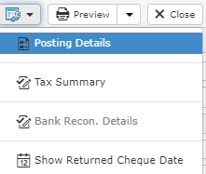

* Under recipient info, a new text field, “Returned Cheque Date” will be added.
* Click **Edit** and enter the returned cheque date.
* Click **Save** once you have compeleted.

**Sample:**

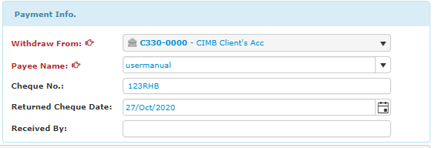

**6.5 Manage Returned Cheque**

* To manage a returned cheque, go to **Manage Pv** and a window will be displayed as below.

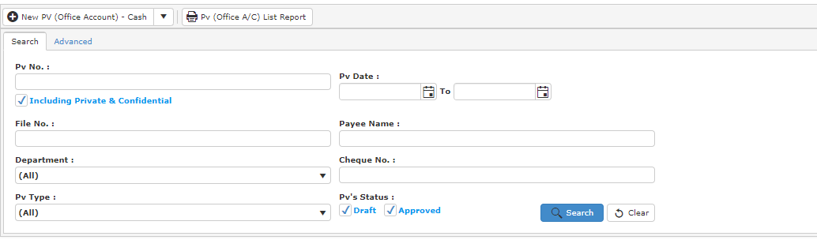

* Click **Advanced.**
* In field, choose returned cheque, fill in a value and click **Add Criteria**.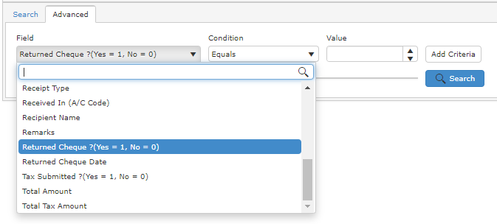
* Click **Search** and a result list will be displayed.

**6.6 Payment Voucher Approval**

* To enable payment voucher approval, go to **System Preferences > Trans. Workflow** and select which PV you wish to have approval.

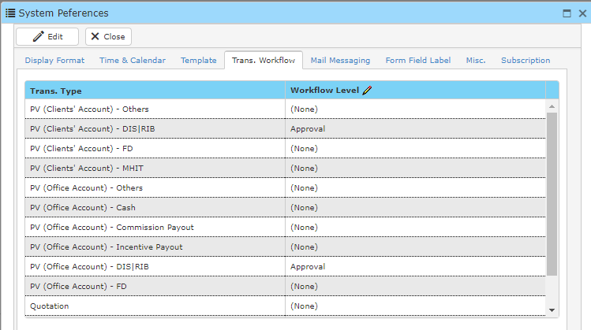

* After approval level has been activated you will see a new category under **Payment** tab.

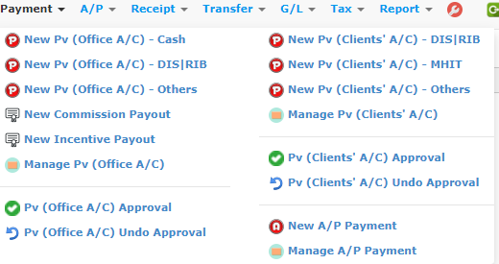

* Go to **PV (Office A/C) Approval** and a new window will be shown as below.

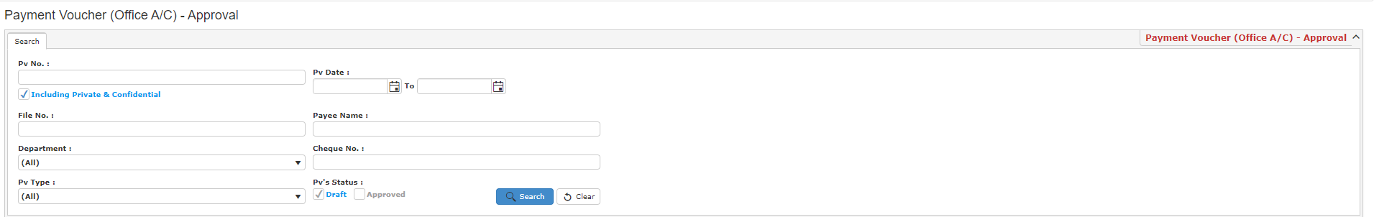

* After entering your search criteria, click **Search** and result will be displayed.

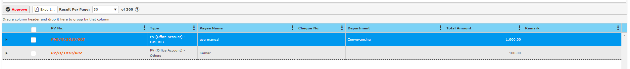

* Tick the checkbox of the PV you want to approve and click **Approve**.
* Click **Confirm** and the PV will be approved.

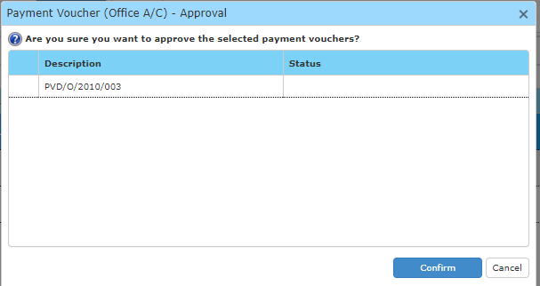

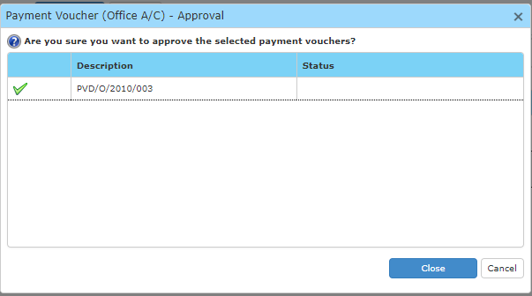

**Undo Approval**

* To undo an approval of payment voucher. Go to **PV (Office A/C) Undo Approval** and a new window will display as below.

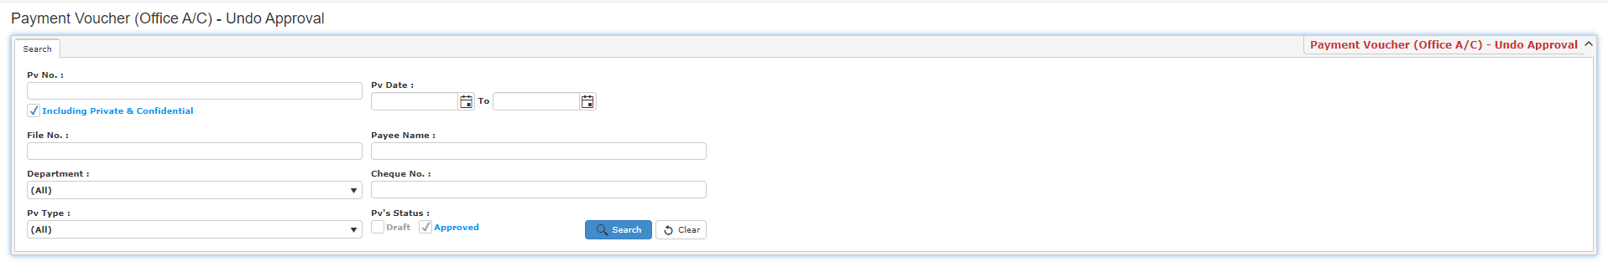

* Enter your search criteria and click **Search** and result will be displayed below.
* Tick the checkbox of the PV you want wish to undo the approval status and click **Undo Approval**.



* Click **Confirm** and undo approval will be carried out for the PV.

